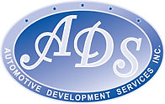
ANNOUNCING
TEAM ONE MARKETING
&
GEORGE ANGUS
F & I TRAINING w/ Special One Day Advanced Session
IS COMING TO
BOZEMAN, MONTANA
MAY 8th, 9th & 10th, 2018

- Team One Groups training and processes produced almost all of the top performers with 89% of the country’s top 100.

- Montana dealers who moved from the “four column menu” to “Team One options menu” have had an average increase of over 30% in “Per Retail Unit Dollars”.

- Faster delivery time, compliant and consumer friendly coupled with increased revenue is why dealers are moving to “Team One approach”.

~ Come Find Out Why ~

To register, please complete registration page and email to christinan@adsfi.com

Take Three Days Out Of The Dealership..
And Come Back With The F & I Secrets That Only The Top Performers Know.
Over the past several years, Team One Group’s training and processes produced almost all of the top performers, with 89% of the country’s top 100 and the majority of the top 500 F & I Managers. On May 8th, 9th, and a special Advanced Class on the 10th, 2018, join this elite group including Mark Nania, Michael Healey, Allen Kobe and George Angus, the top 100 and the overwhelming majority of the top performing F&I departments in the country. Since creating the first old style, four column F&I menus in the early 1990’s, Team One Research and Training has worked with the top F&I managers in the country to develop the best F&I processes and techniques for the F&I Manager. Just look at their results compared to the most popular F&I menus in the market place:
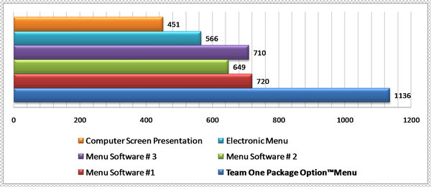
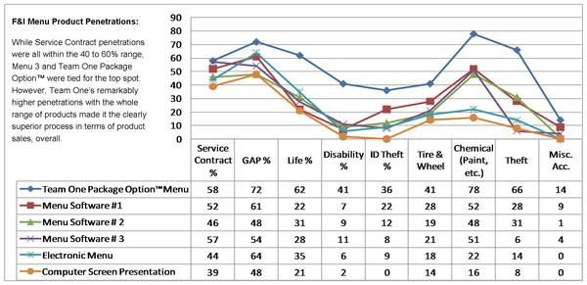
On May 8th, 9th, and 10th, 2018, Automotive Development Services, Inc has subsidized a three day seminar to bring America’s top producing F&I training program, the Team One Package Option™ method, to Montana dealers at an amazingly reasonable cost.

What Will You Learn At This Three Day Seminar?
First, you’ve been working too hard.
Over the last 19 years, through “real world” research and testing in real F&I departments, Team One has identified the keys to F&I success. That’s how we produced the top performers. One of the things we were able to develop is an F&I process that is easy. That’s right. Easy. As a matter of fact, the process we will show you is so easy, you will think it can’t possibly work. But it does.
Second, you’ve been taking too long.
Our top performers are averaging under 20 minutes, total F&I time, including paperwork. How do they do that? It's easy and simple. We'll show you how.
Third, a menu alone won’t do the job for you.
What? The company that created and licensed my menu says it won’t do the job? That’s right. The actual F&I menus are just one small part of a successful process. The menu you use is probably a copy of a copy of (version 2 or 3) that we licensed to a few big F&I companies in 1996.
If you like the menu you have, bring it, we’ll show you how to make it work. Either way, we will give you the menu no one else has, the Package Option™ menu, (version 36), the top performing menu in the country, with Microsoft Excel© based software, as part of your seminar fee. No monthly fees, free.
Yeah, but I hate training!
We understand. Most training classes are boring drawn out affairs with a lot of fluff and theory. Not this one. First, there is no embarrassing videotaping or role playing in front of the group. Second, this event will be conducted by George Angus. If you haven't seen George in action, you won't want to miss this chance. George has worked with, trained, and knows the secrets of the top F&I departments in the country. His lively presentation gets right to the point with real life answers in an easy, simple, fun, and entertaining way. By every standard, George has been ranked by F&I Managers as the best trainer in the country. We promise you won’t hate this training. You will actually have fun while you learn.
Seating for this event will be limited to 30 attendees so call and reserve your place as soon as possible.
Seminar dates are. May 8th, 9th, and 10th, 2018
To get more information:
Contact: Automotive Development Services, Inc.
P. O Box 11669
Bozeman, MT 59719
Mark (406) 581-7778
Allen (406) 595-0839
Michael (509)-424-2263

SPECIAL ADVANCE CLASS
DISCUSSION TOPICS

- Peel off process/ tug
- Cash customers/ conversions
- How to handle line calls
- Ancillary Product Sales
- Lease menu/ product sales
- Product description/ knowledge
- Sale/ turnover process
- Open Discussion
- Salesforce Role- Seed Planting

2018 F&I Training Workshop Registration Form
Seminar Information and registration:
Registration fee includes continental breakfast, lunch and afternoon snacks.
____ Three Day Session-Part I, II & Advanced: May 8th, 9th, and 10th, 2018
____ Two Day Session-Part I & II: May 8th, 9th, 2018
____ One Day Advanced Session May 10th, 2018
Times: Day 1: 9:30 AM to 4:00 PM, Day 2: 9:00 AM to 3:00 PM, Day 3: 9:00 AM to 4:00 PM
Reserve your room at the reduced rate (limited time) for our seminar:
Contact Lindsey Foote:
Element Hotel
406-551-2320
25 E Mendenhall St, Bozeman MT

Complete form & fax to 406-556-9914 or email to christinan@adsfi.com to reserve your seat
Dealership: _______________________________________________________________________
Attendee 1: ______________________________ Email: ___________________________________
Attendee 2: ______________________________ Email: ___________________________________
Attendee 1 Phone: _________________________ Attendee 2 Phone: ________________________
Dealership Address: ________________________________________________________________
City: _____________________________ State: __________ ZIP: _______________
Seminar Pricing:
Attendee 1: ___$490 3-day rate, ___ $390 2-day rate, ___$190 1-day rate (Advanced Session only)
Attendee 2: ___$490 3-day rate, ___ $390 2-day rate, ___$190 1-day rate (Advanced Session only)
Hotel rooms at discounted rate for a limited time only (see number above for reservations)
Please make check payable to: ADS of Montana
Mail to: P.O. Box 11669, Bozeman, MT 59719
Amount Enclosed $__________________
Reservations not paid in full 1 week (7 days) prior to seminar will be cancelled. After that time, cancellations are non-refundable, but may be applied toward a future session. If you do not cancel and do not attend, all fees are non-refundable and non-transferrable. Attendee substitutions may be made at any time. We reserve the right to cancel/reschedule session dates at any time.

